
Department of Computer Engineering & Technology
CSE --- LEVEL 2
Capstone Project Synopsis

Group No. | Name | PRN | Email | Mobile No. | Panel | Signature
P12 | Taha Kapadia | 1032222679 | 1032222679@mitwpu.edu.in | 7385902646 | H
 | Pranjal Vishwakarma | 1032222756 | 1032222756@mitwpu.edu.in | 7987447536 | H
 | Saket Sontakke | 1032222648 | 1032222648@mitwpu.edu.in | 8669618813 | H
 | Akshat Srivastava | 1032222619 | 1032222619@mitwpu.edu.in | 9309456398 | H

Name of Guide: Dr. Pratvina Talele
Project Title: Thermal-Aware Load Balancing Using Physics-Informed Neural Networks (PINN)
Project Domain: AIML, Distributed Systems, High Performance Computing, Physics-Informed
Machine Learning, Sustainable Computing, Green Technology
Name of the Company (for Industry Supported Project only): N/A
Name of the External Guide (for Industry Supported Project only): N/A
Inhouse Project: Yes

Abstract:
In high-density distributed computing, the performance of computational clusters is limited by mechanisms that optimize for computational metrics alone. Conventional load balancing approaches (e.g., Slurm Workload Manager) are typically “thermal-blind”. These schedulers rely on static resource availability, job priority queues, and user-defined hardware requests. They lack a foresight into the effects of temperature and treat heat issues as a secondary event that is handled only after they arise. Standard mitigation techniques rely on reactive hardware-level triggers or simple threshold-based heuristics to reroute workloads. When high-performance accelerators (e.g., NVIDIA V100 GPUs) reach their thermal limit, they automatically throttle their clock speed to prevent hardware damage. This reduction in throughput creates performance degradation that propagates through the entire distributed network and increases total job execution time.
This project proposes a new framework for Physics-Informed Thermal-Aware Load Balancing which will replace reactive triggers with proactive actions. This will prioritize the health and reliability of the hardware alongside performance and efficiency. Unlike standard black-box deep learning models, the proposed architecture incorporates the physical parameters (temperature, power, capacitance, etc.) directly into the neural network’s loss function. This prevents the neural network from predicting thermal behaviours that violate the laws of thermodynamics, ensuring that all resource allocation decisions are grounded in the actual physical capabilities of the hardware.
The MIT Supercloud Dataset is a large-scale repository of high-density cluster telemetry. Usage of this historical data establishes a robust, real-world baseline for performance. This allows for a direct, quantitative comparison between traditional scheduling and the proposed Physics-Informed Neural Network (PINN) approach. The development of an interactive user interface abstracts the underlying complexities and enables users to simulate real-time load distribution and visualizations.

Project Objectives:
- To preprocess and engineer datasets:
  - Preprocess and map GPU data with scheduler logs
  - Calculate baseline ambient temperature and thermal resistance from available time-series data
- To develop a Physics-Informed Neural Network (PINN):
  - Design and train neural network that obey the heat equation constraints
  - Construct a benchmark and evaluate model performance against it
- To implement a thermal-aware load balancing framework:
  - Implement a proactive scheduler that queries PINN for workload assignment
  - Record the temperature of idle GPUs to account for Thermal Inertia
- To build an interactive visualization and simulation interface:
  - Develop an interface to simulate real-time load distribution and display live heatmaps
  - Integrate a Cooling Efficiency slider to simulate various ambient environments

Individual Project Objectives:
Team Member | Contribution
Taha Kapadia | - Preprocess and map GPU data with scheduler logs  - Implement a proactive scheduler that queries PINN for workload assignment
Pranjal Vishwakarma | - Construct a benchmark and evaluate model performance against it  - Integrate a Cooling Efficiency slider to simulate various ambient environments
Saket Sontakke | - Calculate baseline ambient temperature and thermal resistance from available time-series data  - Design and train neural network that obey the heat equation constraints
Akshat Srivastava | - Record the temperature of idle GPUs to account for Thermal Inertia  - Develop an interface to simulate real-time load distribution and display live heatmaps

Software:
Category | Tools & Frameworks | Key Purpose
Machine Learning & Modelling | Python, PyTorch | PINN architecture and model training
Computation | NumPy, SciPy | Data generation and optimized model execution
Frontend/UI | Next.js, React, Three.js | Real-time system & thermal visualization
Backend API | FastAPI | Serving real-time load balancing decisions via REST
Testing & Quality Assurance | PyTest, FastAPI TestClient | Unit testing and API validation of requests/responses
Data & Storage | MongoDB Atlas | Persistence for logs and experiment results
Cloud & DevOps | Vercel, Hugging Face, Git | Full-stack deployment and version control

Hardware:
- Development and testing on standard personal computers
- Training on local GPU or Google Colab (CPU/GPU)
- No specialized hardware sensors are required

High-Level Design (HLD):
A cluster of processing nodes with limited cooling capacity, responsible for processing incoming computational workloads (tasks/jobs), not raw network packets.
1. Data Engineering Module
- Maps GPU telemetry with scheduler logs
- Extracts workload and thermal features from time-series data
- Calculates baseline ambient temperature and thermal resistance parameters
- Creates benchmark from known data
2. Physics-Informed Neural Network (PINN) Module
- Embeds heat equation constraints into the loss function
- Trains neural network and evaluates it against benchmark
- Freezes the best model for inference
- Predicts temperature evolution under varying workloads
3. Thermal-Aware Load Balancing Module
- Receives job requests and queries PINN to evaluate load balancing decisions
- Performs proactive workload assignment based on PINN predictions
- Tracks thermal inertia of idle GPUs
4. Visualization Dashboard and User Interface
- Abstracts all underlying physics and machine learning details
- Provides real-time simulation and heatmaps of load distribution
- Provides a Cooling Efficiency slider to simulate various ambient environments
- Allows visual comparison between different load balancing approaches

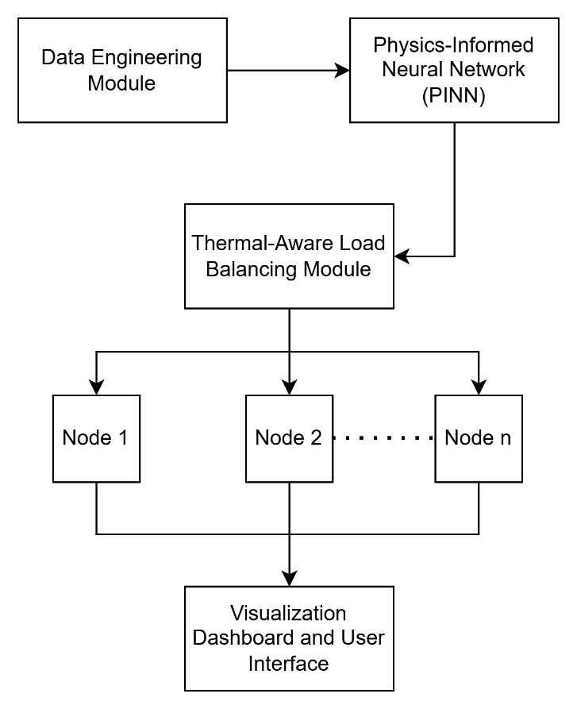
Block Diagram

Residual heat of GPUs that just finished a job and are still hot even if its utilization is 0%.

